**DHCP RELAY**

**STEP 1**

Open the Cisco simulator software and create a network topology for the DHCP as follows  
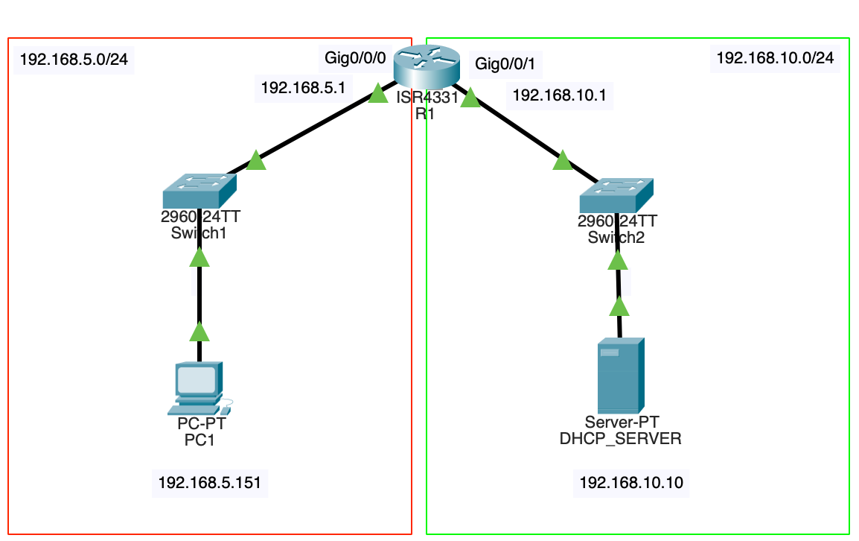

**STEP 2**

Open the Cisco Router R1 CLI command prompt and configure the Router’s GigabitEthernet interfaces as follows

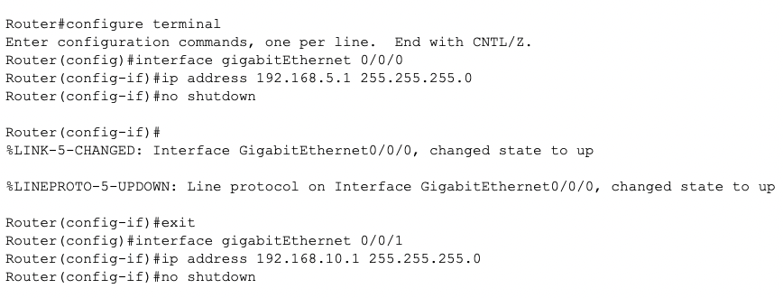

**STEP 3**

Configure the DHCP server on the router as follows.

Here, the purpose of enabling DHCP is to see the difference between Relay Agent. Then we will try to get the IP address from a different location by cancelling DHCP.

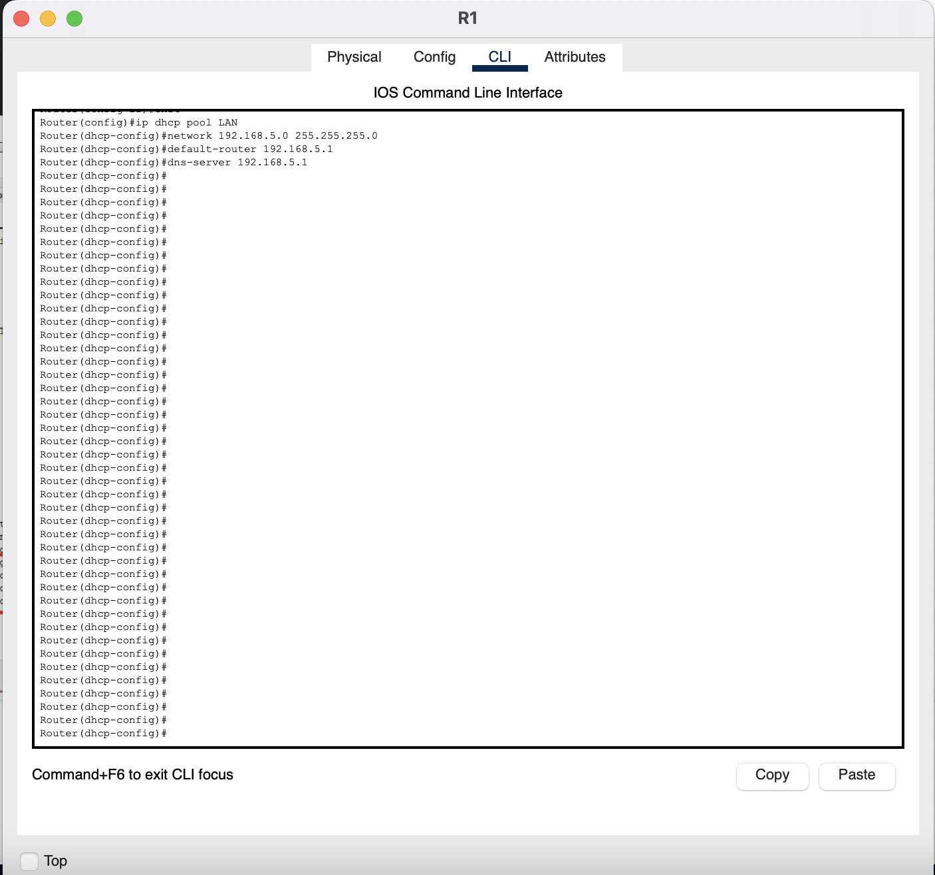

**STEP 4**

Ping the connection form the PCI command prompt to the default gateway.

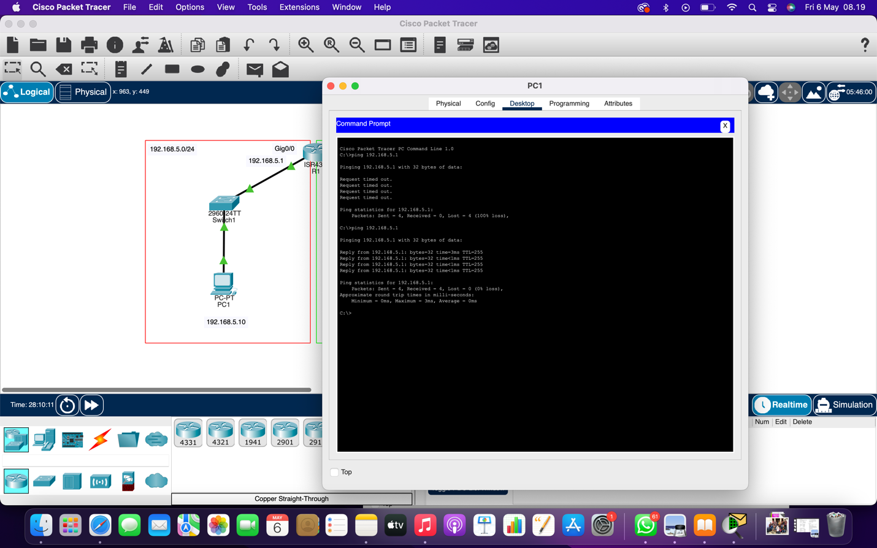

**STEP 5**

Configure the IP Address configuration of PC1 to DHCP and PC1 successfully retrived TCP/IP information from the DHCP server configured on the Router  
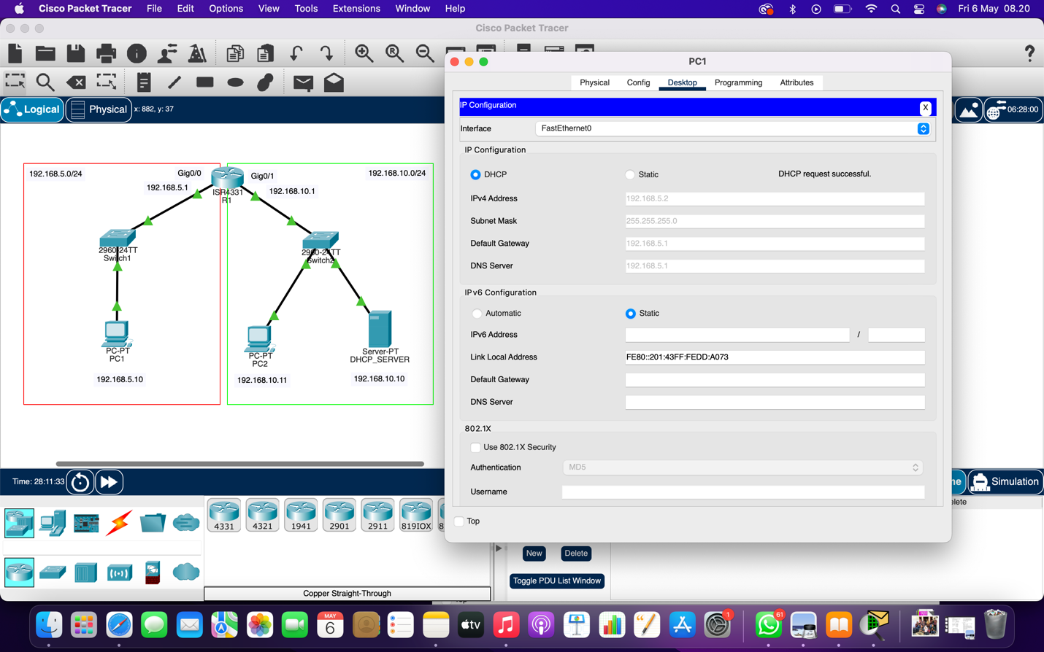

**STEP 6**

Configure the server you added to the 192.168.10.0/24 network as follows and click the Add button to add the configuration to the list. After making sure that the DHCPRELAY pool is added to the list, proced to the next step  
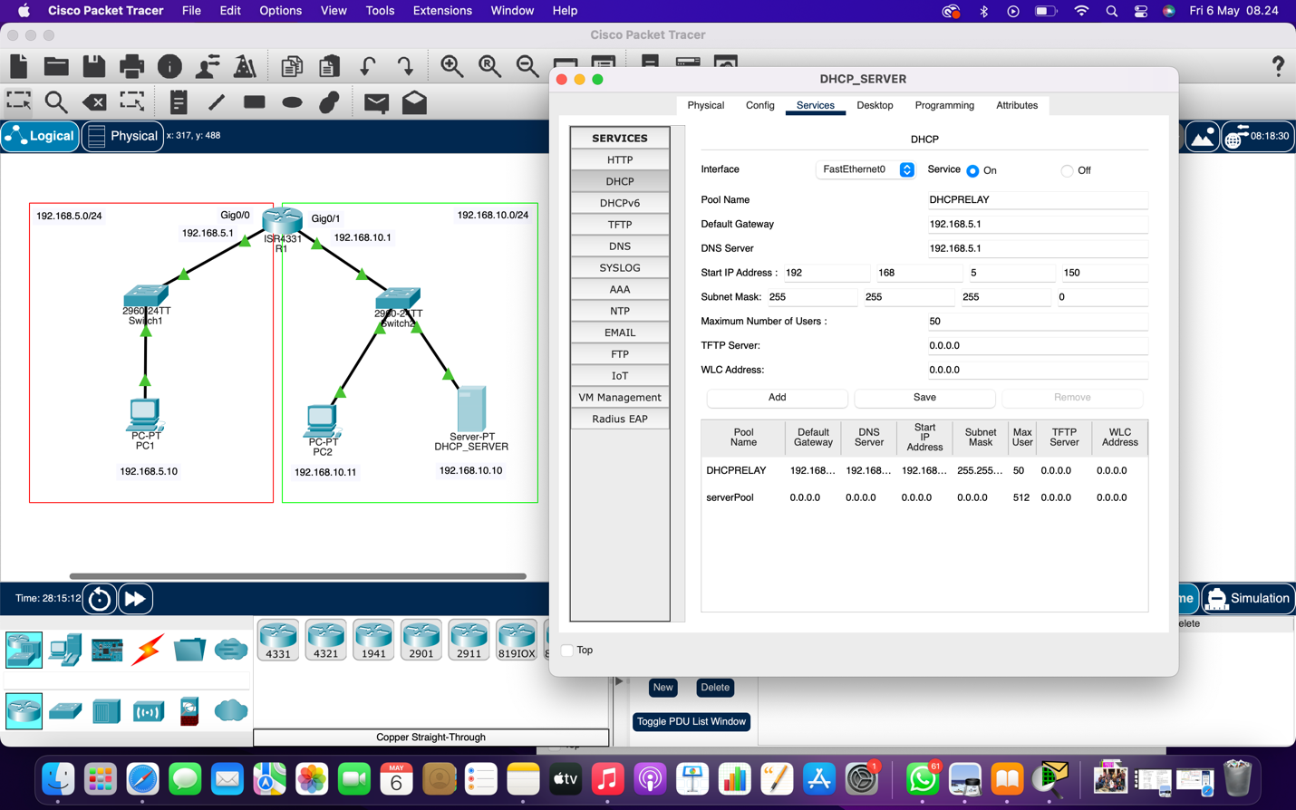

**STEP 7**

Delete the DHCP pool with the **no ip dhcp pool LAN** command, and then execute the **ip helper-address** command on the interface that will act as AGENT.  
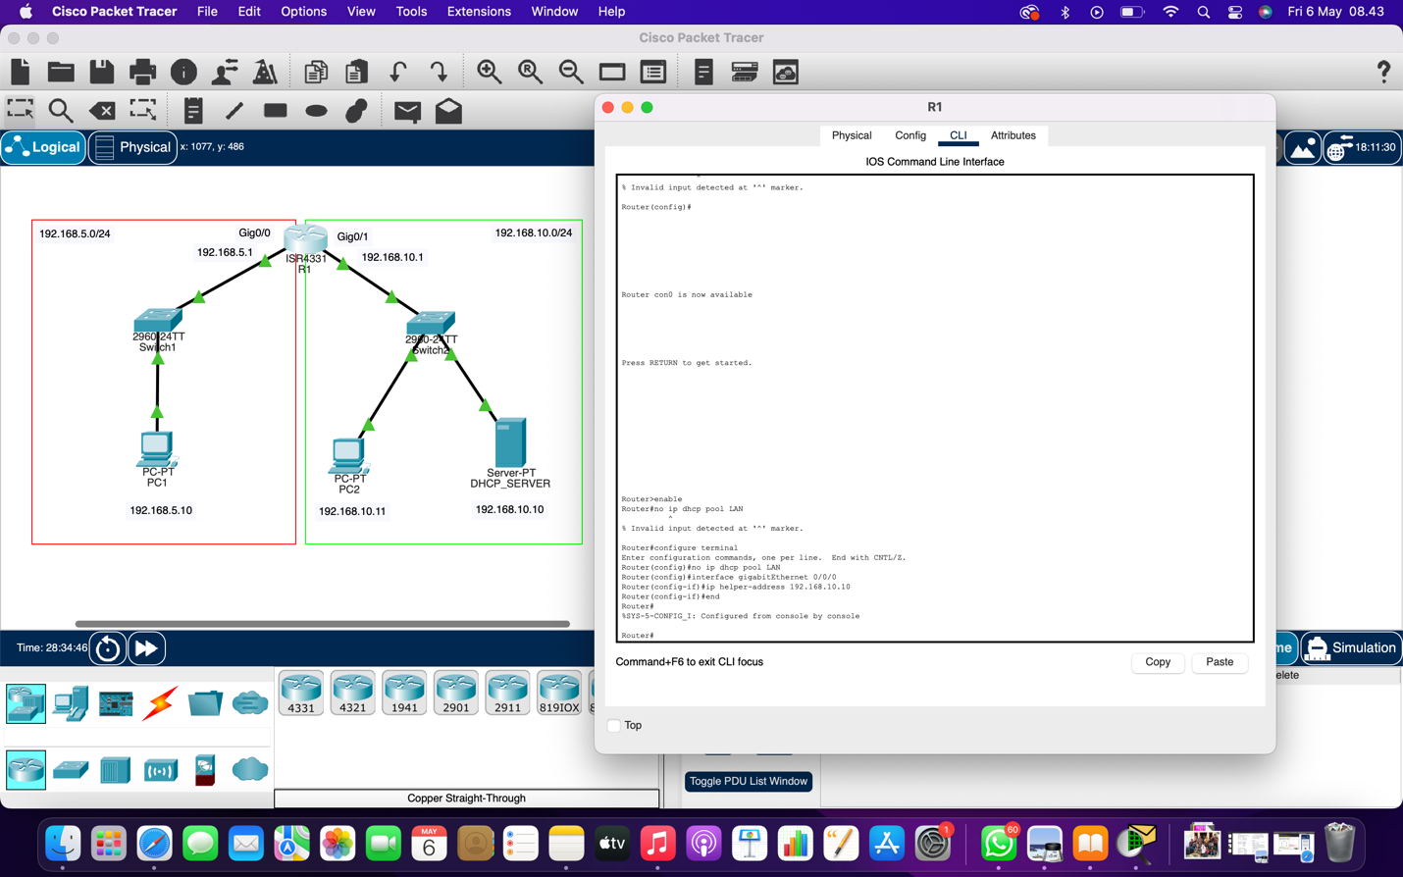

**STEP 8**

Please wait while obtaining the IP address  
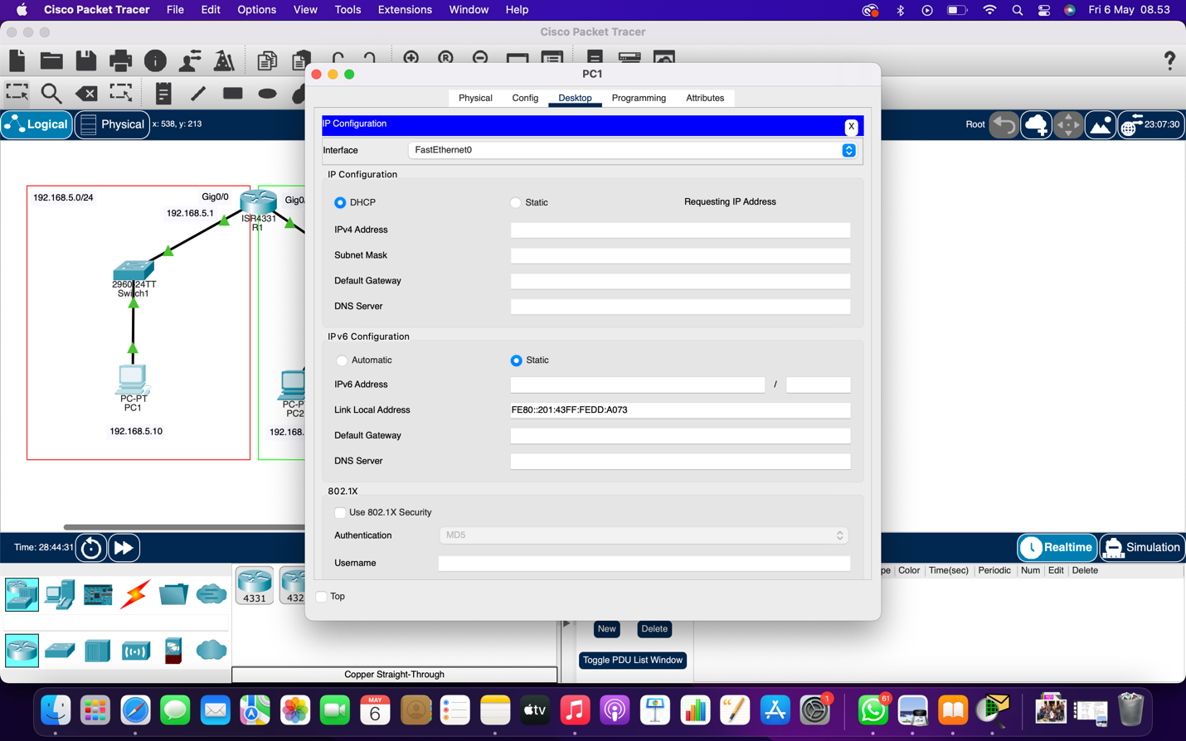

As you can see in the image below, PC1 received its TCP/IP settings from the DHCP Server with IP address 192.168.10.10. You can also see that it receives the IP address from block 192.168.5.150 – 192.168.5.200 in the DHCP pool configured as Agent.

